**Name:** Jaydeep Solanki

**Roll:** 22BEC059

**Practical 3:** Handling Missing Values

Code:

import pandas as pd

csv = pd.read_csv("train.csv")

csv["Cabin"].fillna(csv["Cabin"].mode()[0], inplace=True)

csv["Age"].fillna(csv["Age"].mean().round().astype(int), inplace=True)

csv["Embarked"].fillna(csv["Embarked"].mode()[0], inplace=True)

csv.to_csv('train_complete.csv', index=False)

print(csv)

Output: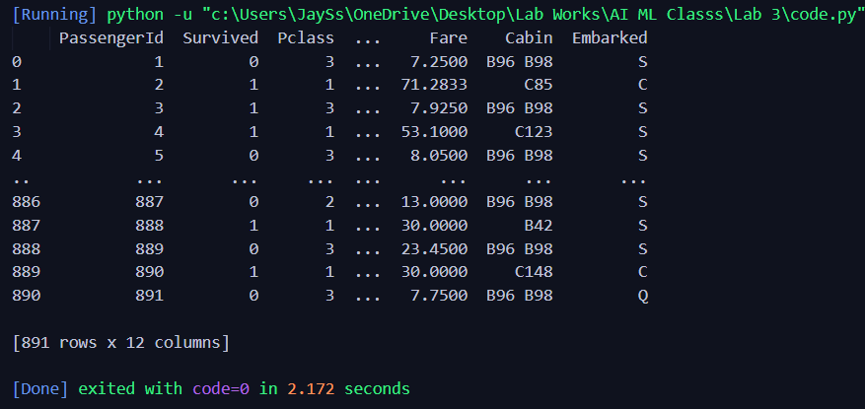

Folder Structure:

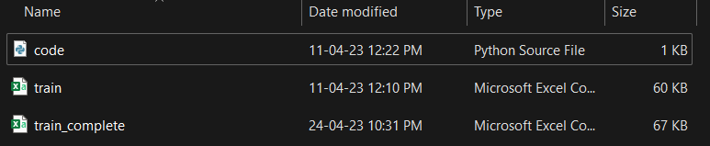

**train.csv** file:

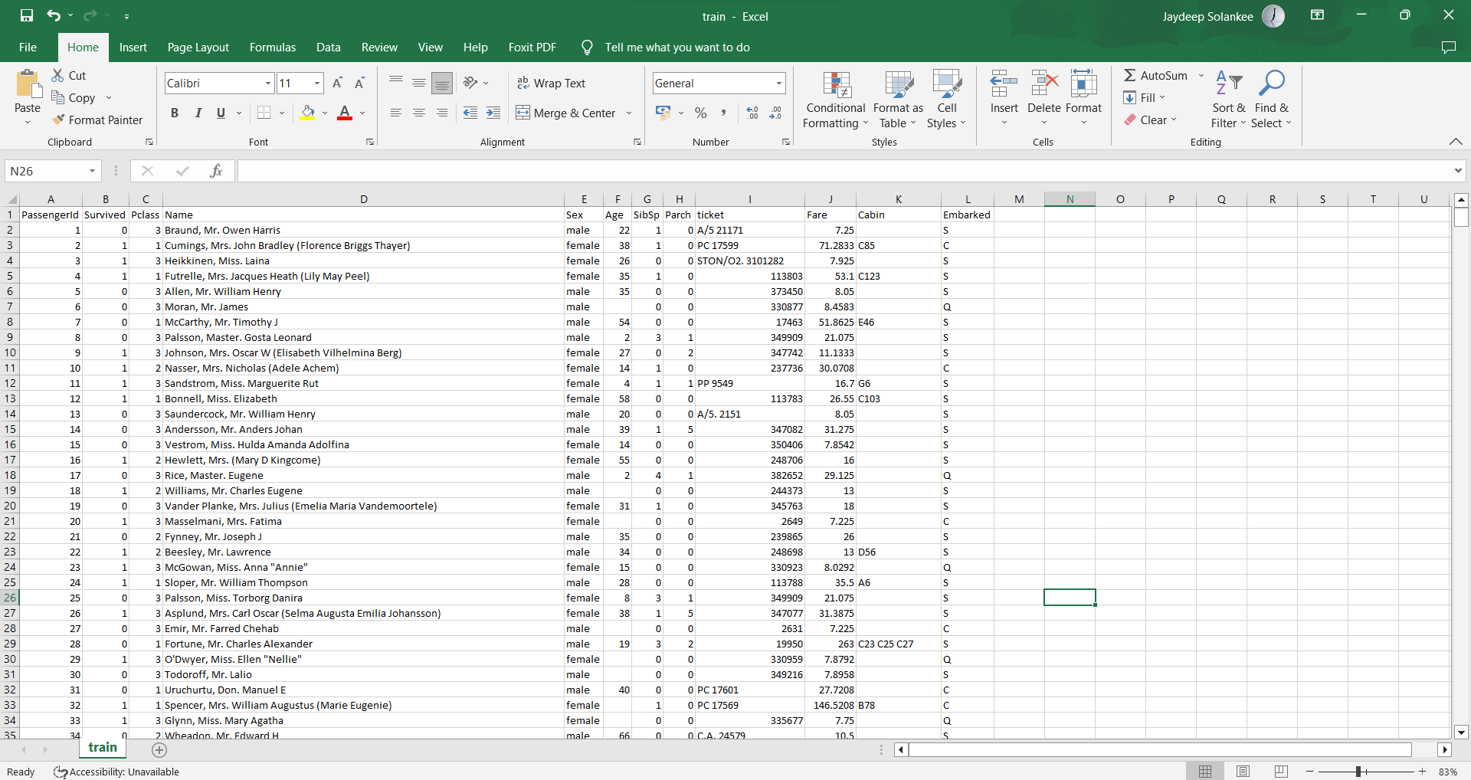

**train_complete.csv** file:

